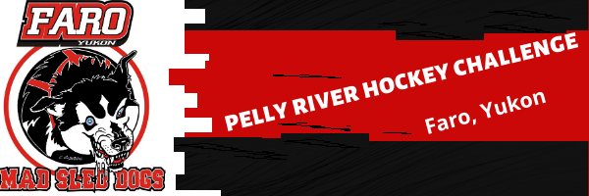
Waiver of Liability
2019 Pelly River Hockey Challenge

- Review, read and understand the “Pelly River Hockey Challenge” Information Sheet
- Review, read, understand and complete the “Waiver of Liability” form
- Please fax or Email the waiver of liability, registration form, information sheet to pellyriverchallenge2019@gmail.com and/or 867-994-2452
Youth Name: _____________________________________________
I agree that I shall provide health insurance to cover any personal injury and property damage sustained by the participant while participating in any activities of the Pelly River Hockey Challenge 2019. The undersigned assumes all responsibility for any and all risk of damage or injury that may occur to the above-named player as a participant in the Pelly River Hockey Challenge, including practices, scrimmages, skills session, clinics, dry land activities, tournament, transportation and other activities related to the hockey camp. Additionally, the undersigned hereby releases and discharges the Town of Faro and the Pelly River Hockey Challenge, its organizing committee, its organizing partners, its volunteers, its instructors, coaches and supervisors, and the professional hockey players and other players from all claims, demands, rights or causes of action present or future, whether known or anticipated and resulting from or arising out of an incident to the undersigned participation in the Pelly River Hockey Challenge. This is also my permission to have my child admitted and attended to, for medical and dental treatment, in case of sickness or injury, that all physicals and inoculations are up to date.
I hereby grant the Town of Faro & Pelly River Hockey Challenge the right to use photographs, video images and/or other media of my child/ward for publicity, advertising and/or other commercial purposes. I understand the event may be photographed, videotaped or otherwise recorded. I agree to let the above parties use my name, photo likeness and demographic information free of charge in any manner and for any purpose in any media now known or hereafter created.

The Pelly River Hockey Challenge has a zero-tolerance policy with respect to uncontrollable behavior, bullying, hazing, alcohol, tobacco, drugs and other controlled substances and weapons of any kind. Any participant possessing any of these will be immediately dismissed from the event.

Page 1 of 2
By signing this release and by being enrolled in the Pelly River Hockey Challenge you consent to the enforcement of this policy and you hereby grant the Pelly River Hockey Challenge and the event organizers the right to inspect any and all personal belongings at any time on or off premises in relation to the event. Times and schedule are subject to change. I understand that this document is intended to be as broad and inclusive as permitted and agree that if any portion of this agreement is invalid, the remainder shall continue in full legal force and effect.
By signing this form, I declare that I am the legal parent/guardian of the child listed above and have read the above waiver and agree to its conditions. I further understand that my child/ward will be expected to take part in all activities, at all times. As an extra precaution in case of illness/injury or for disciplinary reasons, I or my emergency contact will be available to answer my phone at any time and may be required to attend Pelly River Hockey Challenge to pick up my child/ward.
Signed Parent/Guardian:____________________________________________________
Print Parent/Guardian:______________________________________________________
Date: ______________________________
Signed at (City/Town/Community) _________________________________
Witness of signature, Print & Sign: ______________________________________________________________
Signed at (City/Town/Community) ______________________________________________________________

